Getting the ball wide and delivery

This session looks at phases of play to get the ball wide.
Movement off the ball is vital to get into goal scoring positions.

By David Baird

After a good warm up start with the following drill:

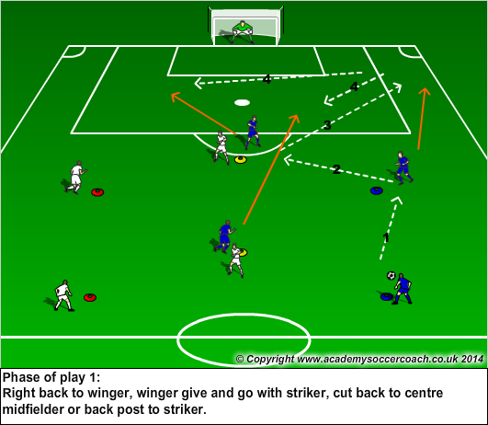

Instruction:
The blue team will perform the phase of play, once the shot on goal has been taken, the white team should start as the blue team make their recovery run back to their starting positions. The aim is to complete the phase successfully, avoiding the traffic of the returning players. Speed of play challenge – complete the phase and shoot before the other team are back on their markers

Coaching:
Encourage the winger to check away from the play then back, asking for the ball to feet. The defender should play the wingers back foot so he can play 1 or 2 touch into the striker who should have also have checked away then to the ball, moving the defender away momentarily.
The return ball should be played in front of the winger.
Midfielder should time his run to just inside the box for a cut back and first time shot. Attacker should be the back post option – staying onside and looking for rebounds

Progression 1:

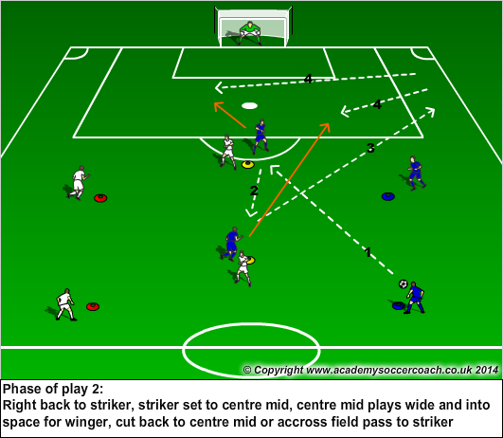

Conditioned Game:

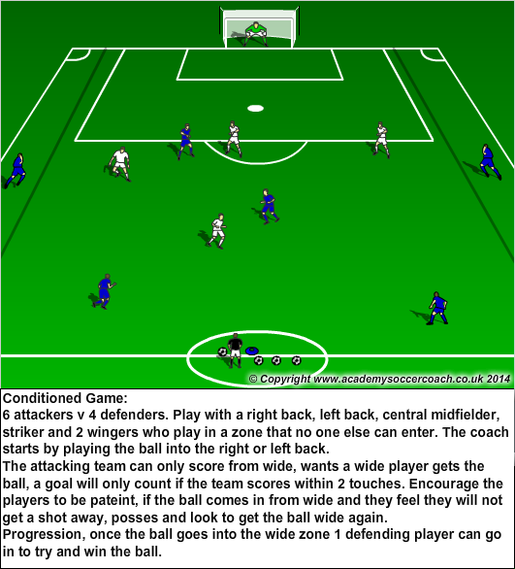

More: Football Drills and Sessions

